**Utilizing Browser Storage**

* the focus lies on the browser because that's the first place where you typically work with Javascript
* Now in the HTTP module, we had a look at how you can store data and also fetch data from inside avascript to and from a server
* Now some data however can also be stored in the browser, so directly where your user is

**Browser Storage Options**

* the web page runs in the browser
* it's served by a server
* most web applications also talk to a server, either behind the scenes through Javascript or by using the default browser behavior

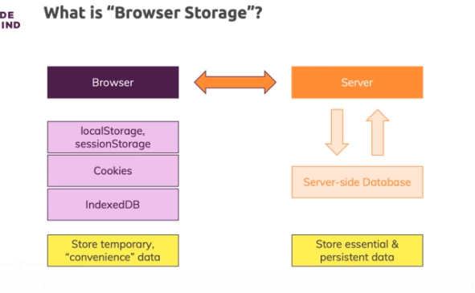

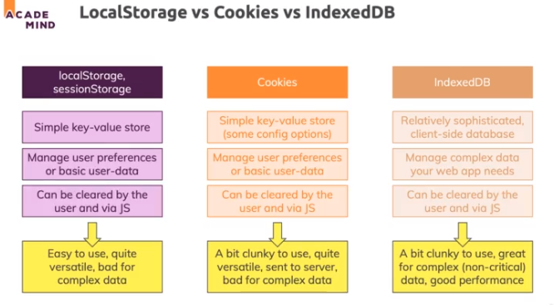

**LocalStorage & sessionStorage**

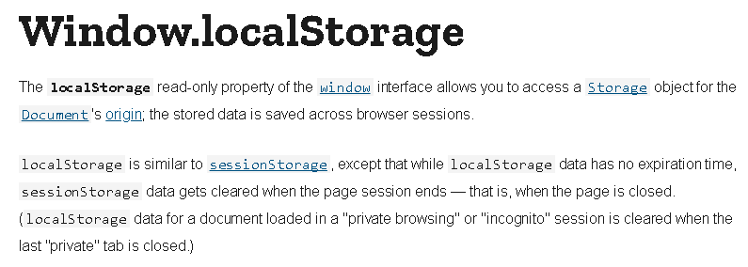

* Local storage is a great, easy to use key-value storage where you can store basic data

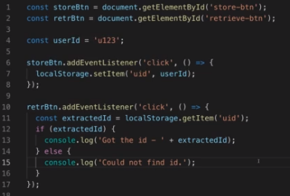

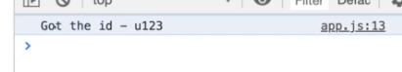

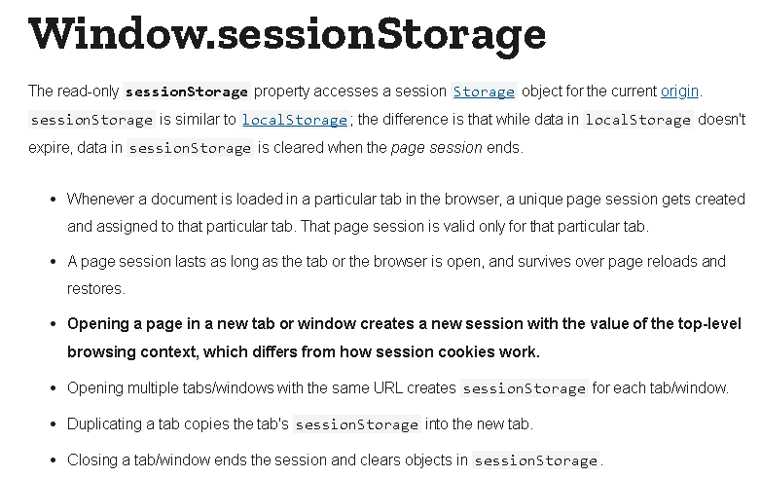

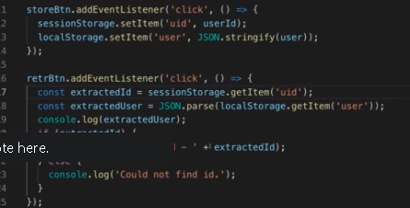

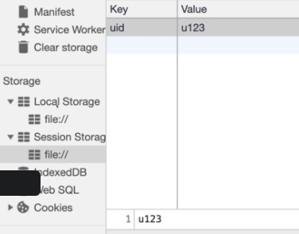

**Getting Started with Cookies**

* Now cookies are these special storage in a sense because they are attached to outgoing HttpRequests
* you need some server side code which also reads the cookies so that this actually is an advantage
* We access the cookies with documents.cookie

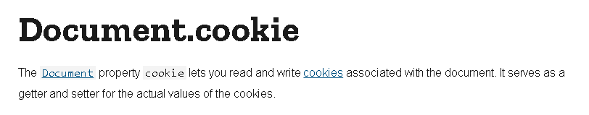

* cookies really only are available if your web page is getting served with a real serve

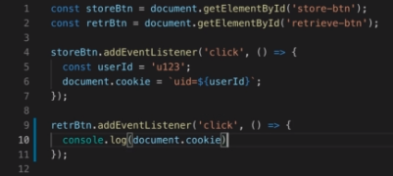

**Getting Started with IndexedDB**

